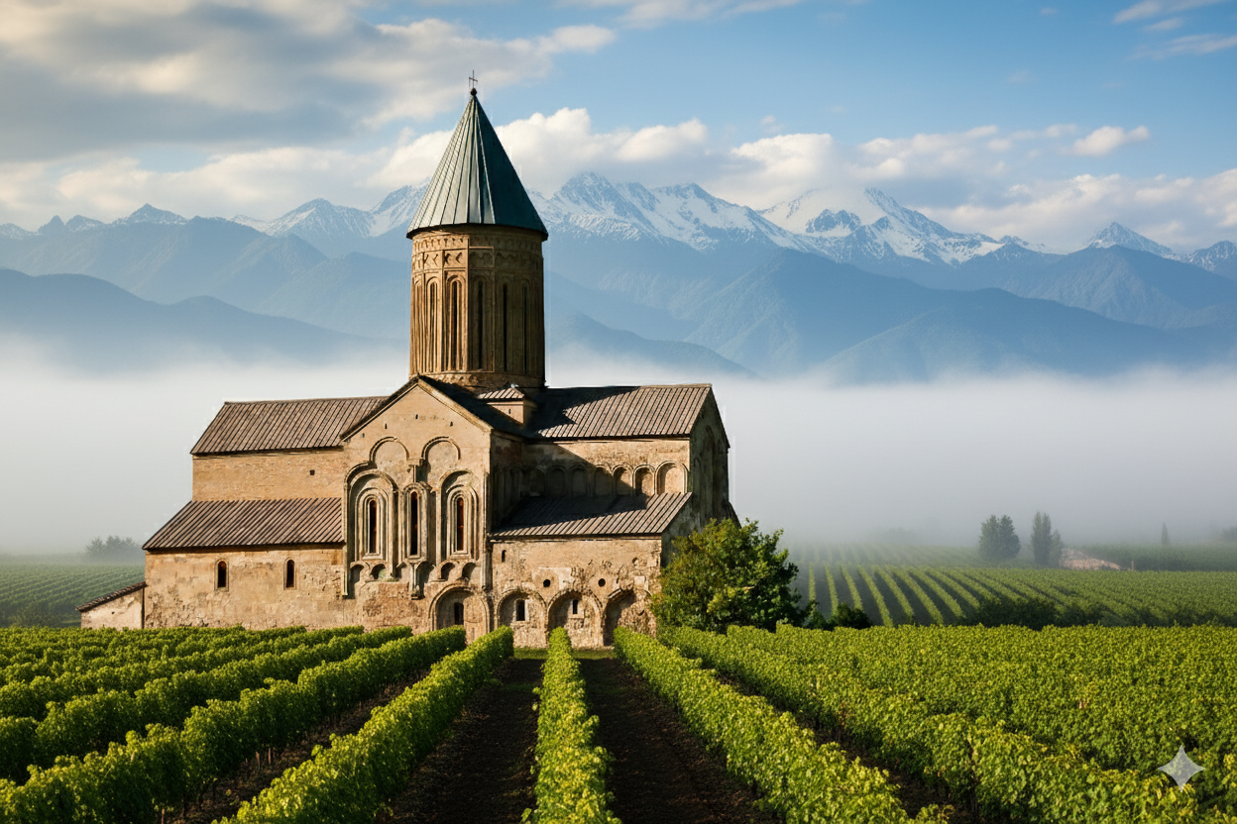

# CHÂTEAU ALAVERDI 1782

Georgia’s winemaking soul — refined for the world.



## Our Story

For 8,000 years, Georgia has been the cradle of wine. Château Alaverdi 1782 carries this timeless heritage forward with a modern, château-level approach. Named in homage to the restoration year of the sacred Alaverdi Monastery, each bottle expresses the land, the light, and the centuries of devotion that define Georgian wine.  
  
At Château Alaverdi 1782, we unite the spiritual depth of Georgia’s winemaking tradition with the refinement of European craftsmanship. Every drop is a celebration of authenticity, elegance, and soul.

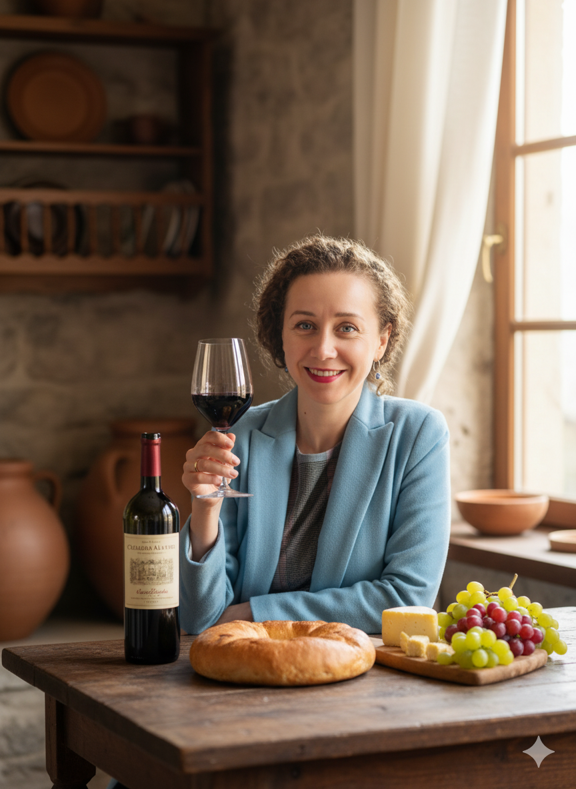

## Terroir — Kakheti

Region: Kakheti, Eastern Georgia — sun-filled valleys, mineral-rich soils, and centuries of winemaking wisdom.  
Vineyards: Hand-harvested grapes from family plots around Alaverdi.  
Philosophy: Minimal intervention. Maximum expression. True Georgian soul.

## The Craft

Blending ancient qvevri fermentation with modern cellar precision. Qvevri — the clay vessel of Georgia — allows for natural temperature regulation and gentle maceration, producing profound aromas, texture, and longevity.

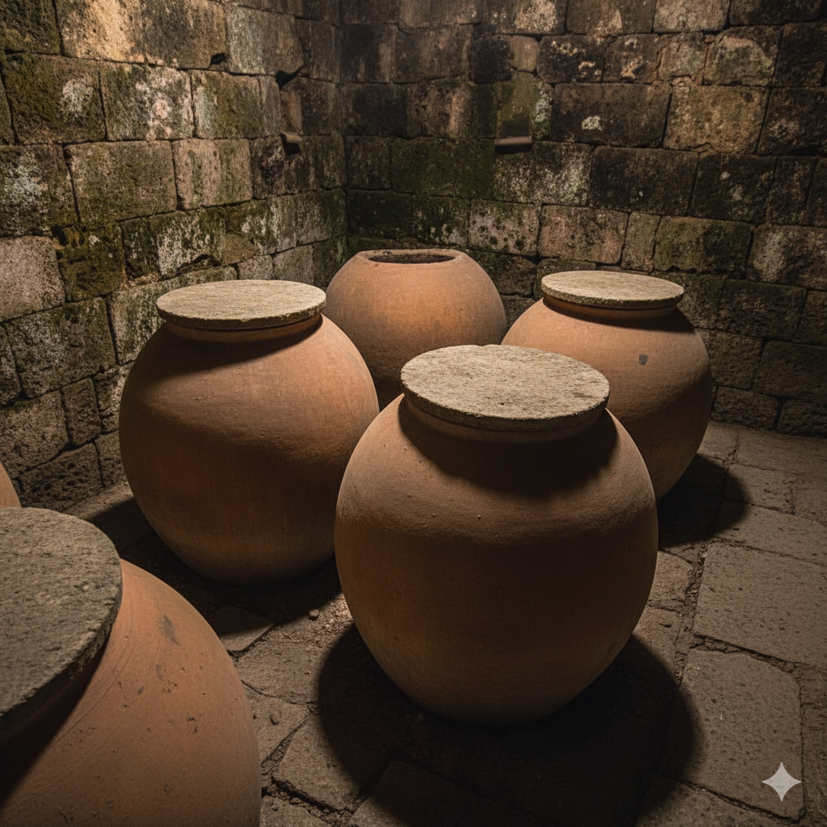

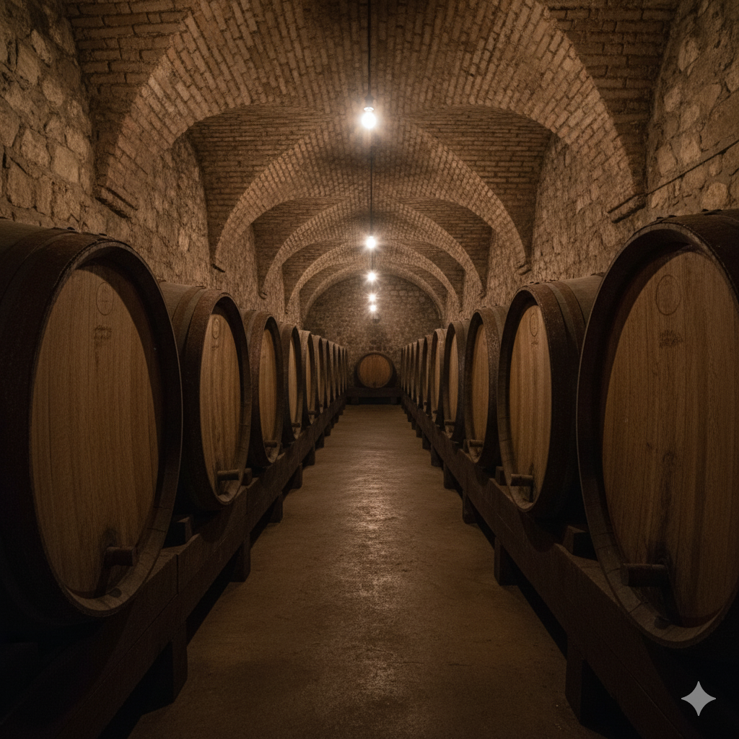

## Our Wines

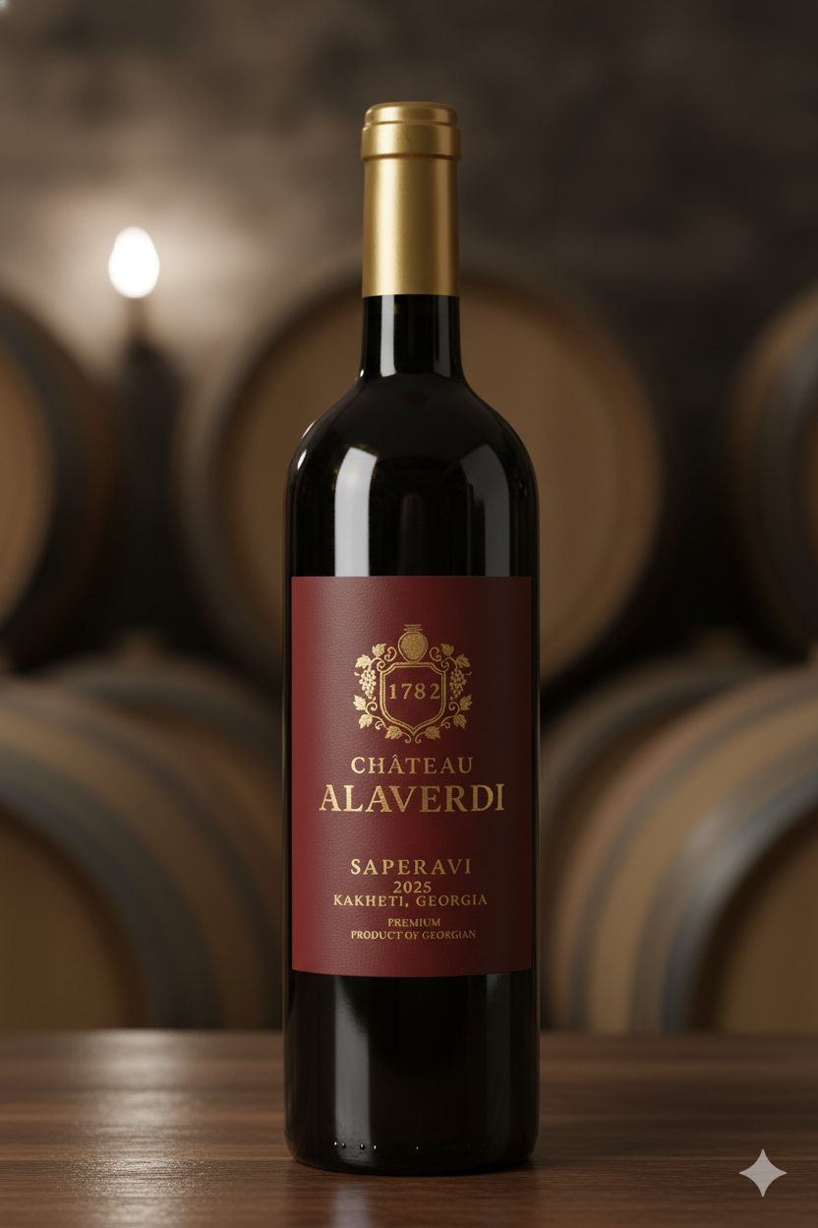

Alaverdi Saperavi 1782 — Reserve Red  
Dry Red Wine | 100% Saperavi | ABV 13.5–14% | 750 ml  
Deep ruby-garnet. Aromas of black cherry, plum and graphite. Rich, structured palate with elegant tannin, cedar spice and a long mineral finish. Oak-aged 12–18 months.  
Pairing: Roasted lamb, aged cheeses, dark chocolate desserts.

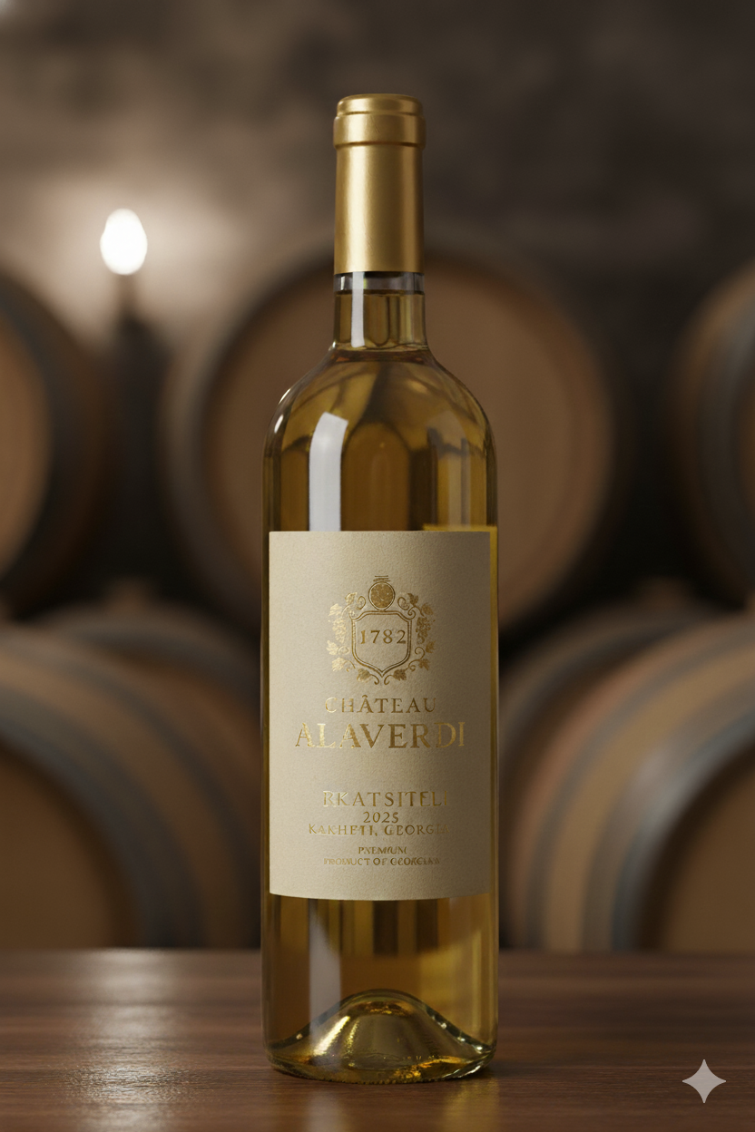

Alaverdi Rkatsiteli 1782 — Classic White  
Dry White Wine | 100% Rkatsiteli | ABV 12.5–13% | 750 ml  
Golden amber hue. Fragrant notes of pear, quince, and wild honey. Textured, layered, and elegant with a vibrant acidity. Long, savoury finish.  
Pairing: Grilled fish, spice-forward vegetables, and light poultry.

## Export & Distribution

Export Inquiries & Samples: export@chateaualaverdi.com

Commercial & Distribution: kristina@chateaualaverdi.com

Phone / WhatsApp: +995 555 345 542

Logistics: FOB Tbilisi; typical lead time 8–12 weeks. Support: POS materials, staff training, digital assets, and launch events.





Left: WeChat | Right: Website https://chateaualaverdi.com